Simple Ticket Booking System in C
Project Report
Course: C Programming
Student: Shashank
Institution: UPES

Abstract
This project presents a simple ticket booking system developed using the C programming language. The system allows users to view seat availability, book tickets, and cancel bookings through a menu-driven interface. The project demonstrates the use of arrays, loops, conditional statements, and switch-case control structure.

Problem Definition
The objective of this project is to design and implement a basic ticket booking system. The system should allow users to:
1. View seat status
2. Book a seat
3. Cancel a booked seat
4. Exit the program
The system maintains a record of 20 seats where each seat is marked as booked (1) or empty (0).

System Design
Algorithm:
1. Initialize an integer array of 20 seats set to 0.
2. Display menu options using a loop.
3. Use switch-case to handle user choices.
4. For booking and cancellation, validate seat numbers.
5. Update seat status based on user input.
6. Continue until the user chooses to exit.

Implementation Details
#include <stdio.h>
int main() {
int seats[20] = {0};
int choice, seatNo, seatcn;
while(1){
printf("\n---SIMPLE TICKET SYSTEM---\n");
printf("1. Show Seats\n");
printf("2. Book Ticket\n");
printf("3. Cancel Ticket\n");
printf("4. Exit\n");
printf("Enter choice: ");
scanf("%d", &choice);
switch(choice){
case 1:
printf("\nSeats Status (0 = Empty, 1 = Booked):\n");
for(int i = 0; i < 10; i++){
printf("Seat %d : %d\n", i+1, seats[i]);
}
break;
case 2:
printf("Enter seat number to book (1-20):");
scanf("%d", &seatNo);
if(seatNo < 1 || seatNo > 10)
printf("Invalid seat number!\n");
else if(seats[seatNo-1] == 1)
printf("Seat already booked!\n");
else{
seats[seatNo-1] = 1;
printf("Seat Booked successfully!\n");
}
break;
case 3:
printf("Enter seat number to cancel (1-20): ");
scanf("%d", &seatcn);
if(seatcn < 1 || seatcn > 20){
printf("Invalid seat number!\n");}
else if(seats[seatcn-1] == 0){
printf("Seat is already empty!\n");}
else{
seats[seatcn-1] = 0;
printf("Booking cancelled!\n");
}
break;
case 4:
printf("Exiting...\n");
return 0;
default:
printf("Invalid choice!\n");
}
}
}

Algorithm
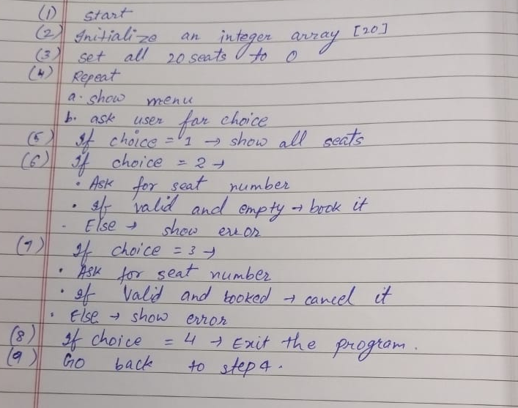

Testing & Results
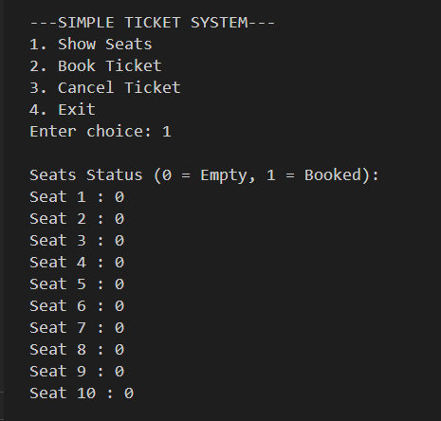
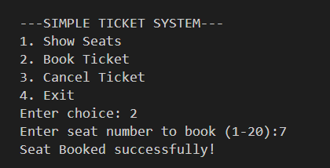
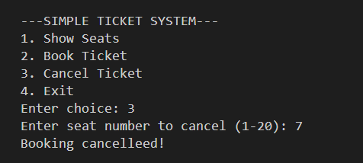
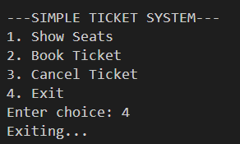

Conclusion & Future Work
The ticket booking system effectively demonstrates the use of arrays and control structures in C. Future enhancements may include adding user authentication, dynamic seat layout, file storage, and graphical interface.

